**Biorefrigerator Security System**

Biomedical Engineering Senior Design

Dr. Aijun Wang

Progress Report 3

Winter 2024

Team 1

Brayden Chipman - 3/8/24 7:48 PM

Miguel Cruz - 3/8/24 6:17 PM

Ashwin Halepet - 3/8/24, 5:36 PM

Vance Padilla -3/8/24, 8:24 PM

**Table of Contents**

# 

**Problem and Objective 2**

Problem Statement 2

Design Objective 3

Design Solution 3

Design Updates 3

**Verification and Validation 4**

Recognized Consensus Standards 5

Standards to Meet 5

Verification 6

Verification Process Flow 6

Individual Component Verification 7

Subsystem Device Verification 10

Validation 12

Future Development/Small Scale Development 13

Large-Scale Validation 14

**Preliminary Hazards Analysis 15**

Failure Modes and Effects Analysis (FMEA) 15

FMEA Analysis/Discussion 19

Risk Mitigation Strategies 20

**Societal Impact 21**

Value Proposition 21

Ethical Considerations 21

Green Engineering 22

Regulatory Pathway 23

**References 25**

**Appendix 26**

Figure 6: House of Quality 26

Preliminary Verification Test Protocols 27

Figure 7: Circuitry Diagram 32

Table 6: Complete Failure Modes and Effects Analysis 33

Table 7: Engineering Design Specifications 37

Table 8: Bill of Materials 38

# **Problem and Objective**

Figure 1: Introductory Figure for the Design

# 

We are 3rd and 4th year students enrolled in UC Davis’ BIM 110, “Biomedical Engineering Senior Design”. We have been assigned to work on a project proposed to us by Dr. Aijun Wang and PhD candidate Yongheng Wang. Over the last two quarters, we have developed the Biorefrigerator Security System depicted above. This device’s function is to prevent the loss of biological samples that are stored in a controlled laboratory environment (CLE), such as a -20 C or -40 C freezer, thus preventing the associated monetary loss that results from the loss of samples. This device works by using a passive, hydraulic door closer to prevent the CLE door from not fully closing. Furthermore, this device also has a PIN pad to ensure that only members of the lab who are using the CLE can access the samples. Additionally, the device has an alarm system to alert users that either an event of unauthorized access occurred, or if the door is propped open.

## **Problem** Statement

Current methods of ensuring that a frequently accessed CLE remains closed are limited by the need for human input. Humans typically interact with the CLE by opening or closing the doors manually. Requiring the use of human input introduces the possibility of human error. Some newer models of CLE’s have methods to signal that they are left open such as audible alarms. However, older CLE models may not have a method to signal that they are accidentally left open. The most common error of human input in CLE’s is accidentally leaving them open. Exposure to room-temperature should be minimized and have been proven to negatively affect biological material, especially proteins, over time. For example, even short periods of thawing and refreezing can lead to mild denaturing and minor loss of proteins. Ten cycles of thawing and refreezing already show at least over 5% loss of many types of proteins [1]. Ideally, it would be best to prevent this situation from constantly occurring because the loss of integrity can then lead to time and monetary loss.

## Design **Objective**

The objective of the Biorefrigerator Security System is to develop a device that minimizes the risk of sample deterioration due to prolonged exposure to ambient conditions. We aim for the device to be power efficient, affordable, easy to install, and easy to use. Primary intended use cases are CLEs such as chemical and biological laboratory refrigerators, as well as incubators.

## Design Solution

Our design solution is a device that enables automatic closure of CLE doors without the need for laboratory workers to intervene. The main housing of the device will be installed on the door of the CLE, and the arm will be attached to the top of the CLE. A hook-style lock system is attached atop the closer housing in order to resist opening the CLE when in the locked state. The main housing of the device will contain a PIN pad that users will use to lock and unlock the CLE. The door status is considered “closed” when a limit switch that is placed in the door is pressed. Once not pressed, the door status will read as “open”. The LED and speaker alarms are set to trigger when the door status changes to “open” when the locked status is “locked” or when the door is open for over two minutes. The device will be powered by disposable or rechargeable 9V batteries (as supplied by the end user). Figure 1 above illustrates the device when fully assembled.

### **Design Updates**

Since the last progress report, we have some possible changes that will be made. The design integrates a weighted mechanism with a spring and sensor for reliable door closure and incorporates a PIN pad lock for secure access, activating a sound and light alarm if opened without the code. This mechanism doubles as a failsafe, closing the door automatically as well as addressing concerns about unauthorized access. Version 1 of the design depicted a rough design made of mostly aluminum with a PIN pad, speaker, LED, and hidden sensor, while Version 2 refined the design on Solidworks, incorporating hydraulic closers and detailed alarm placements. Version 3 introduces further improvements such as a larger PIN pad housing for a battery holder, wire channels, and a servo-hook locking mechanism to prevent accidental openings, enhancing user accountability without requiring high security measures.

Currently, due to the difficulty of working with aluminum, we have changed the main body to be made of stainless steel. Additionally, we are inserting a display screen into the body so that the PIN code is visible while the user is typing it in. This change also comes with a change in the type of microprocessor, which will make bluetooth connection possible, which would allow us to make an app that provides a user log of the CLE. Since a method of monitoring the individual users who access the CLE is secondary to the objective of keeping it from opening, we will only implement such a feature if time and resources allow.

# **Verification and Validation**

The importance of performing verification and validation tests is to close the loop on the waterfall design process. The waterfall design process is a loop of how a medical device is made starting from user needs and ending with a medical device. The waterfall design process uses user input to come up with design ideas. After thoughts and considerations involving prioritizing certain components and ideas over others, as well as rating how each factor would affect the design, a design idea is chosen to be processed to be built. After the design is created, the device is subject to verification tests to ensure that the device can function properly. After verification, validation can be performed which can test the efficacy of the use of the device for usage in the market. What we accomplished this quarter was selecting the materials needed, understanding the risks and preventative measures involved in the project, as well as coming up with validation and verification plans to ensure that the device meets user engineering specifications and user needs. The next step in the design process is prototyping and performing the verification testing detailed in this report.

Figure 2: Waterfall Design Process

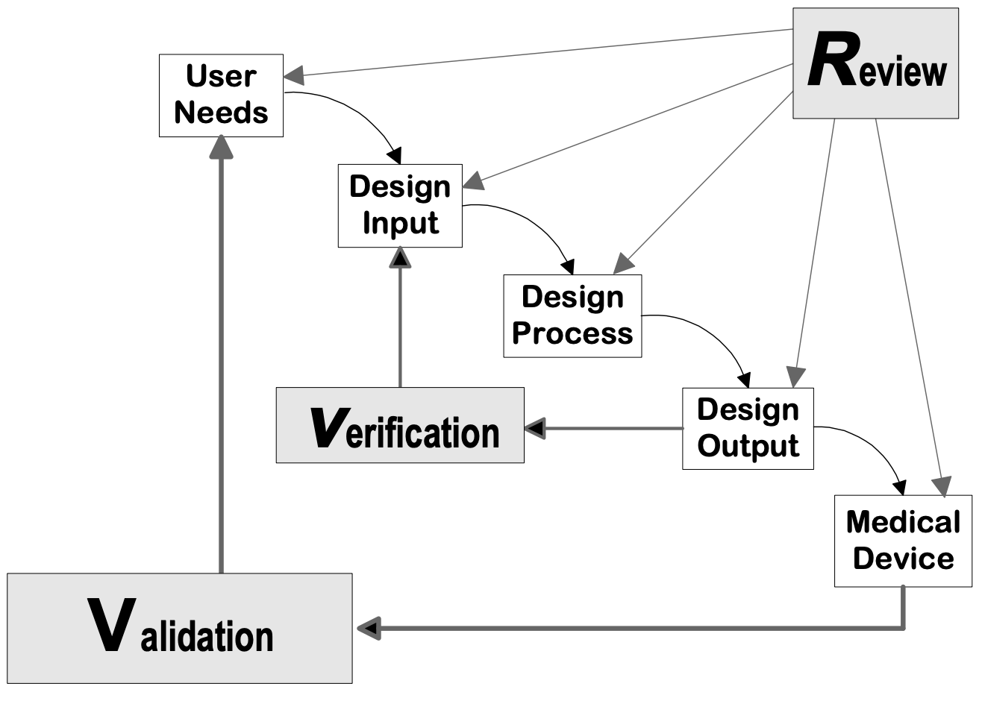

In order to follow the design practices of medical devices, we are going to follow the Food and Drug Administration’s (FDA) Quality System Regulation 21 CFR Part 820. Designed to help in the design and production of medical devices, this regulation details the verification and validation pathways. These pathways are used to help serve as a framework for quality assurance as well as help guide the design process. Verification will focus on ensuring that our device meets the requirements given in our Engineering Design Specifications (EDS) (shown in the appendix), while validation will focus on ensuring that the user needs and intended use is satisfied. The EDS table was also based on the House of Quality (HOQ) also shown in the appendix. However, some factors in the HOQ have been removed or not considered due to lack of relevance in our current designs. Recognized Consensus Standards must be also given to meet the regulations of the FDA.

According to the FDA, the definition for a medical device is an instrument that is either known in the National Formulary or United States Pharmacopoeia, a way to diagnose or cure or lessen the severity of a disease, or affects the body of a human or an animal in some way [2]. A CLE lock system with a PIN pad and alarm is not recognized by the FDA as a way to diagnose, mitigate, or cure a disease, nor does it affect the body of a human or an animal, therefore we believe it would not be regulated as a medical device. Regardless, to ensure a higher quality product, we aim to meet medical device regulatory standards whenever possible.

## Recognized Consensus Standards

Based on a thorough search of the FDA Recognized Consensus Standards website, only one applicable Recognized Consensus Standard was found. This is UL 1642 for lithium batteries, which is meant to “reduce the risk of injury due to fire or explosion” [3].

Given the emphasis on electrical safety and reliability in devices used in laboratory settings, following the relevant standards is of utmost importance. In this context, a device that consists of an alarm and locking device should meet standards for electrical safety, functionality, and reliability. To ensure that these standards are met, the following section goes over verification processes to ensure that all components and systems function properly along with validation testing to ensure the system works as intended in meeting user needs. Here are the following standards we will be using:

## Standards to Meet

Table 1: Standards Table

| **Standard** | **Description of Standard** |
| --- | --- |
| ANSI C18.1M-2021 | This standard refers to portable primary cells and batteries for the purpose of ensuring electrical and physical interchangeability, minimizing proliferation, and defining a standard of performance. |
| ANSI/BHMA A156.4-2019 | This standard pertains to door closers, outlining specifications and requirements for their design, testing, and performance. It ensures the reliability and safety of door closer mechanisms in various applications. Evaluations conducted under this standard include those of door control, durability, appearance, and pivots. |
| IEC 60601-1-8 Ed. 2.2 b:2020 | This standard relates to medical electrical equipment, specifically focusing on the alarms and alarm systems used in medical devices. It provides guidelines for the design, testing, and implementation of alarm systems to ensure their effectiveness and reliability in alerting healthcare professionals to potential issues. |
| Occupational Safety and Health Standard 1910.95 | Occupational Noise Exposure: This standard pertains to the maximum noise level that workers can be exposed to for varying lengths of working hours. |
| IEC 63356-2 Ed. 1.0 b:2022 | This standard focuses on LED light sources. It outlines requirements and testing procedures to ensure these components' reliability, safety, and performance in electrical systems. |

## Verification

The goal of verification tests is to confirm all used materials are functional prior to assembly. This is to ensure that no other factors can affect future tests. This phase includes an assessment of the battery, microcontroller, and closer. Afterward, we will test components as a subsystem and finally test the entire system overall. This will help us focus on ensuring that our devices meet the requirements given on our EDS.

### **Verification Process Flow**

Figure 3: Verification Flow Chart

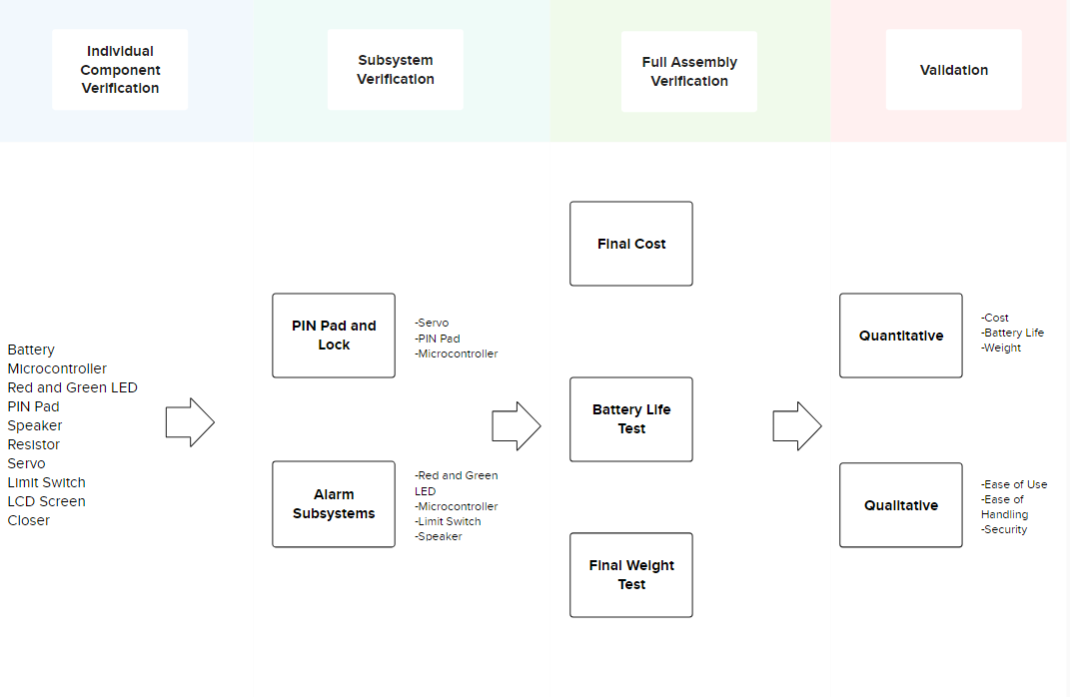

### **Individual Component Verification**

This subsection will list out each individual component’s purposes and test protocols in order to explain how each component will have their individual verification tests for function. Small-scale test protocols and large-scale test protocols have also been included. We will use small-scale test protocols for our prototyping. Large-scale test protocols are the steps given when mass manufacturing of the device occurs. Large-scale test protocols are similar to small-scale protocols with added details and steps.

**Battery**

*Purpose:* To ensure that the circuitry and program are effective when active, we must confirm the batteries are properly working. Testing will involve measuring voltage and battery life.

*Standards To Meet*: ANSI C18.1M-2021

*Small-Scale Test Protocol:*

1. Turn on the multimeter
2. Turn the dial to the voltage setting 15V
3. Touch the red probe to the positive terminal and the black probe to the negative terminal
4. Note the voltage shown
5. Perform an average and standard dev.
6. After getting voltage, test for maH using the multimeter over 1 minute, then divide by 1000 to get aH
7. After getting maH, test how much energy the microprocessor draws using the multimeter over 1 minute (both idle and when activating the servo)
8. The battery life is now: V*aH(battery) / wH(microprocessor) to get the hours that the battery will last
9. The acceptable range is 6-12 months
10. Obtain data from other sources and base our results on results from data

*Large-Scale Test Protocol:*

1. Randomly select 10% of batteries
2. Perform the small-scale test
3. Perform a T test against the target value of 6 months
4. Ensure that the null hypothesis is accepted

**Microcontroller Component Testing**

*Purpose:* By testing each component of the Arduino, we will effectively find any defect that might exist before Validation testing.

*Standards To Meet:* IEC 60601-1-8 Ed. 2.2 b:2020 | Occupational Safety and Health Standard 1910.95 | IEC 63356-2 Ed. 1.0 b:2022

*Small-Scale Component Test Protocols:*

Adafruit METRO M0:

1. Turn on the AdafruitMETRO
2. Install Arduino IDE into METRO
3. “Hello World”
   1. See if it outputs the code
   2. Code in for a simple LED system, with a resistor
      1. Test for AdafruitMETRO, if code works with circuitry, then Adafruit works
      2. Possibly test for multiple pins

Red and Green LED:

1. Add a resistor in series with each cathode
2. Plug into the microcontroller and output 2.1V into the red LED pin
3. See if the red LED lights up
4. Turn off the 2.1 V output
5. Output 2.4 volts into the green LED pin
6. See if the green LED lights up
7. Turn off the 2.4V output

PIN Pad:

1. Activate and program in a certain passcode for the PIN pad
2. Type in the passcode
3. If the correct passcode is entered, the lock status will change to “unlocked”

Speaker:

1. Use the METRO to program an alarm sound of frequency 1 Hz and 100% volume level
2. Measure the sound level from 2 feet away
   1. If the sound level is higher than 85 dB, adjust until it is 85 dB or lower
   2. If the sound level is inaudible or softer than the conversational level, the speaker has failed

Resistor:

1. Turn on the multimeter
2. Turn the dial to the resistance setting 20kΩ
3. Touch the red probe to one of the metal wires on the resistor and the black probe to the other wire
4. Note the resistance shown
5. Perform a one sample T test against the rated resistance

Servo

1. Program in code with specific angle degrees
2. Note the initial position of the servo, then Note the new position of the servo with the programming, if the difference between the new position and initial position is set similarly to the programmed code, then the servo works.

Limit Switch

1. Turn on the multimeter
2. Turn the dial to the lowest resistance setting
3. Touch the test leads to the terminals of the limit switch
4. Press down the lever arm of the limit switch
5. Note the resistance from the multimeter
6. Release the lever arm
7. Note the resistance
8. Resistance should be low when the lever is pushed down, and high when released

LCD Screen

1. Connect screen to METRO
2. Code METRO to output a 32-character long word to screen
3. See if all cells on the screen can display a character

*Large-Scale Test Protocol:*

1. Randomly select 10% of each component
2. Test using the small-scale test procedures
3. Mark each sample with pass or fail based on the results of the previous step
4. Ensure that at least 90% of the components pass
5. Discard any failed components

**Pressurized Door Closer:**

*Purpose:* As the main component of the device, testing the closer will be important so that the status of the door can change with the closer component present.

*Standard To Meet:* ANSI/BHMA A156.4-2019

*Small-Scale Test Protocol:*

1. Test the range of motion of the closer arms
   1. The segment of the arm directly connected to the rack and pinion should have a range of motion of approximately 360 degrees
   2. The other segment of the arm should have a range of motion of approximately 180 degrees
2. Install the device onto the intended controlled laboratory environment
3. Test the Air Pressure Release Valve
   1. Open and close the door of the laboratory environment and observe the security and smoothness of closing. The door should close smoothly without slamming

*Large-Scale Test Protocol:*

1. Randomly select 10% of pressurized door closers
2. Test using the small-scale test procedures
3. Mark each sample with pass or fail based on the results of the previous step
4. Ensure that at least 90% of the door closers pass
5. Discard any failed components

**Attachment System (Epoxy)**

*Purpose:* An epoxy attachment system is how the lock system is attached to the CLE. This test is required to ensure the system can be applied properly on the CLE.

While there was no relevant standard for the use of epoxy resin as an adhesive, the team has deemed it necessary to verify the ability of the adhesive to adhere the device to the CLE. This is to ensure that the adhesion will be able to withstand certain forces such as gravity and the force exerted by the pressurized door closer.

*Small-Scale Test Protocol:*

1. An L-shaped stainless steel plate with a hole drilled through the exposed arm will be epoxied onto a stainless steel test device
2. Attach a luggage scale to the stainless steel plate
3. Pull the luggage scale until the plate comes off
4. Note the scale reading of the maximum force required to pull the plate off

*Large-Scale Test Protocol:*

1. Randomly select 10% of samples.
2. An L-shaped stainless steel plate with a hole drilled through the exposed arm will be epoxied onto a stainless steel test device
3. Attach a luggage scale to the stainless steel plate
4. Pull the luggage scale until the plate comes off
5. Note the scale reading of the maximum force required to pull the plate off.
6. Ensure that 90% of each sample works and discard the ones that do not work.

### **Subsystem Device Verification**

We will verify the subsystems of the device first then finally move onto verifying the entire system functions together properly. Subsystems are grouped based on the microprocessor’s two functions: Alarm and PIN Pad/Lock system.

**Microprocessor Subsystems:**

*Purpose:* These tests are final testing before the whole system is tested together. This test will be used to confirm circuit and programming aspects work effectively together before taking into account the physical aspect of the device. For more information on the entire microprocessor circuit system, refer to the Appendix for the Circuitry Diagram.

*Standards To Meet:* IEC 60601-1-8 Ed. 2.2 b:2020

*Small-Scale Test Protocol:*

1. Alarm
   1. Connect the speaker and LED to the Adafruit Metro in accordance with the circuit schematic
   2. Program the speakers and LED to alarm when the limit switch detects an open door and to turn off when it detects a closed door
      1. Press down on the limit switch and print the current door status to the display
      2. Ensure that the current door status displayed is “closed”
      3. Release the limit switch and print the current door status to the display
      4. Ensure that the current door status displayed is “open”
2. PINpad/Lock system
   1. Connect PIN pad and screen to METRO
   2. Program the lock to activate and deactivate off a default code (1111) then test if it does so
      1. Connect the PIN pad and servo to the Adafruit Metro
      2. Set the door lock status to be “locked”
      3. Print the current door lock status to the display
      4. Input the default code into the PIN pad
      5. Print the current door status to the display, which should now be “unlocked”. The Servo arm should rotate upwards and not block the closer arm
      6. Input the default code into the PIN pad
      7. Print the current door status to the display, which should now be “locked”. The Servo arm should rotate downwards and block the closer arm

*Large-Scale Test Protocol:*

* 1. Connect PIN pad and screen to METRO
  2. Program the lock to activate and deactivate off a default code (1111) then test if it does so
     1. Randomly select 10% of samples.
     2. Connect the PIN pad and servo to the Adafruit Metro.
     3. Set the door lock status to be “locked”.
     4. Print the current door lock status to the display.
     5. Input the default code into the PIN pad.
     6. Print the current door status to the display, which should now be “unlocked”. The Servo arm should rotate upwards and not block the closer arm.
     7. Input the default code into the PIN pad.
     8. Print the current door status to the display, which should now be “locked”. The Servo arm should rotate downwards and block the closer arm
     9. Repeat this test 10 times. Ensure that 90% of the tests work.
     10. Discard any samples that do not work.

**Full Assembly Verification**

*Purpose:* As the final test, this test will be done to ensure the entire system all together is effectively working as designed.

*Small-Scale Test Protocol:*

1. The system locks the door when necessary, closes the door in most cases, and sounds an alarm when specified
2. Test system similar to an intended day in the lab
   1. Unlock the system with the PIN pad to unlock the servo
   2. Open the door and close it and test if the system detects the door is closed
   3. Test leaving the door open for 3 minutes and test when the speaker and LED go off
      1. Note: the system is supposed to alarm at 2 mins. Testing for 3 minutes will help discover unwanted or unnoticed factors.
   4. Repeat the previous two tests a couple of times
   5. Close the door, final test, if the alarm detects the door, is closed
   6. Lock the system using the PIN pad

*Large-Scale Test Protocol:*

1. The system locks the door when necessary, closes the door in most cases, and sounds an alarm when specified
2. Test system similar to an intended day in the lab
   1. Randomly select 10% of samples.
   2. Unlock the system with the PIN pad to unlock the servo
   3. Open the door and close it and test if the system detects the door is closed
   4. Test leaving the door open for 3 minutes and test when the speaker and LED go off
      1. Note: the system is supposed to alarm at 2 mins. Testing for 3 minutes will help discover unwanted or unnoticed factors.
   5. Repeat the previous two tests a couple of times
   6. Close the door, final test, if the alarm detects the door, is closed
   7. Lock the system using the PIN pad
   8. Repeat the above steps on ten separate refrigerators
   9. Ensure 90% of the components pass
   10. Discard any failed components

## Validation

Validation tests will involve both small and large-scale assessments to confirm functionality, durability, and usability. The small-scale testing will focus on testing during the prototyping phase, while large-scale testing is based on hypothetical plans for testing past the scope of this class’ timeline.

Table 2: Small Scale Testing

| **Test** | **Metric** | **Test Protocol** | **Target** |
| --- | --- | --- | --- |
| Cost | US Dollars | 1. Sum final costs of components and materials | $150 or less |
| Battery Life | Months | 1. Use a multimeter to measure voltage before usage and then again after 1 hour. 2. Repeat 3 times. 3. Use the average difference in voltage per hour to calculate the theoretical battery life. 4. Repeat for all 4 batteries and perform a T test. | 6 months or more |
| Weight | Pounds | 1. Weigh the final assembly with a digital scale. 2. Perform a one sample T test with the hypothetical target value. | 10 lbs or less |
| Passive Operation | Door Status | 1. Install the final assembly on the intended CLE 2. Open the CLE door    1. The door status should read as open. 3. Let go of the door and let the device close it automatically    1. The door status should read as closed | Status shown is accurate to real life |

Our gross cost for the whole assembly should be under $150 per unit, since our initial surveys indicated that people would pay $100-$150 for a lock. So far, our design choices have let us prototype a product that is roughly around $150 in value of the parts used in the final design even though we have spent more than that in overhead for research and development. Once we produce our product in bulk, individual part costs will go down and could give us room to gain a profit margin while charging $150 or less.

Ideally for battery life, the ideal user experience would be one in which the user does not have to be concerned about the battery running out. Since typical uses of 9-volt batteries have 6-month lifetimes, we will also be aiming for a minimum 6-month lifetime between battery changes with the battery life tested as according to our verification plans above.The final weight of the assembled device should be light enough to comfortably carry and mount on a CLE, so under 10 pounds would be ideal. This number is arbitrary, since the National Institute for Occupational Safety and Health (NIOSH) sets an upper limit for lifting a load with 2 hands as 51 lbs [3]. While this isn’t a regulation by OSHA, but instead just a guideline, our device is already far lighter than this guideline. Therefore, our self-imposed 10 pound limit is the maximum weight we have set for both lifting and mounting a device comfortably for an able-bodied person.

Finally for the operation of the device, the minimum is that the device successfully closes the door while making it still able to be opened while not exerting too much force, which is no more than 5 lbs according to the ADA [4]. Along with this, it should also be able to read the status of the door as open or closed.

## Future Development/Small Scale Development

In the future after more devices are created and sold, our plan is to encourage customers to fill out a survey on their satisfaction with the product. This survey will gather information on metrics such as how easy our devices were to set up and operate. Along with the survey, we will be testing random units in line with the validation, verification, and failure modes tables laid out in this report. If we find that any of our metrics are measured to be outside of our desired range, we will implement plans to improve the design and issue recalls if an outstanding issue is discovered. For example, if we find that the speaker we decided to use has a chance of being too loud for OSHA requirements, we will issue recalls and replace the speaker with a different one. An example of an issue that does not warrant a recall would be if our suppliers for materials increased prices, causing the cost of manufacturing to be too high. In a situation like this, we would find new suppliers and organize our manufacturing to account for it.

## Large-Scale Validation

The large-scale validation testing will involve testing to see if the project is feasible for use or not, as well as ensuring that the device can be sellable. Important factors for ensuring the device is feasible for people to use and for the device to be marketable include cost, battery life, weight, and passive operation. Cost is important since people prefer less expensive products to pay for over more costly products. Average battery life is important since the batteries in the lock device need to last a long time so that people do not need to change the batteries frequently. Average weight is important since the device cannot be too heavy or else people will have a hard time moving the lock when necessary. Passive operation is important so that the function of the alarm and PIN pad for passcode entry can function. An alarm should be audible and visible for people to see if it is on. A PIN pad should be able to be easy and use a friendly way to stop the alarm and unlock or lock the CLE. The table below sums up the large-scale testing that will be done to ensure all these factors mentioned are met.

Table 3: Large Scale Testing

| **Test** | **Metric** | **Test Protocol** | **Target** |
| --- | --- | --- | --- |
| Average Cost | US Dollar | 1. Sum final costs of components and materials along with manufacturing, 2. Divide the sum per unit | $150 or less |
| Average Battery Life | Hours | 1. Use [small scale test] on a randomly selected 10% of batteries 2. Perform a T test 3. Ensure that tested batteries fall within the target values | 6 months or more |
| Average Weight | Pounds | 1. Weigh 1 in 10 random units 2. Perform a mean and standard deviation with groups of 10 different units | 10 lbs or less |
| Passive Operation | User Rated Score | 1. Provide a survey to end users    1. Survey will contain a section for passive operation | Average score of 7 or more |

# 

# **Preliminary Hazards Analysis**

## Failure Modes and Effects Analysis (FMEA)

**Introduction**

To be aware of any hazards on our device we will construct a *Failure Mode Effects Analysis (FMEA)* following the guidelines given by the American Society of Quality (ASQ). Below are two tables.

Table 4 determines the scale of FMEA Events. They will be broken up into Occurrence (OC), Severity (SV), and Detectability (DT) each having a scale from 1-10 for the purpose of having more specificity. Risk Priority Number (RPN), which is the multiplication of SV, OC, and DT, has been given appropriate scaling by the team as shown in the table. Having Unacceptable Risk is deemed extremely dangerous and additional safety measures must be included to address this risk. Scores given for Acceptable Risk and Unacceptable Risk were chosen based on the expected scoring below 3 for all points of OC, SV, and DT for Acceptable Risk and the expected scoring of 4 for all points of OC, SV, and DT for Unacceptable Risk.

Table 5 is a summary of the FMEA chart for our device. Refer to the appendix for the full FMEA chart. We will first select the item that must be considered for FMEA guidelines. There will be a Potential Failure Mode or a situation in which damage or error may occur. A scale value for Occurance will be given. Then, there will be Potential Effects regarding the situation. A scale value for Severity will be given. Current Control will be stated on the chart to explain how the situation will be noticed. A scale value for Detectability will be given. Finally, an RPN value will be displayed with a Mitigation Strategy to try to prevent the situation from happening in the first place.

Table 4: FMEA Scoring Table

| Occurrence (OC) | 2 = Almost never  4 = Rare/Possible  6 = Occasionally  8 = Often  10 = Extremely Often/all the time |
| --- | --- |
| Severity (SV) | 2 = No safety concerns, but minor effect on functionality of device  4 = Minor injuries and/or minor effect on functionality of device  6 = Minor injuries and/or major effects on functionality of device  8 = Moderate injuries and/or major effect on functionality of device, user needs are not met  10 = Extreme injuries and/or major effect on functionality of device, user needs are worsened |
| Detection (DT) | 2 = Easily detectable (User can see problem immediately)  4 = Detectable (User can make an educated guess on where the problem has occurred)  6 = Moderately Detectable (User can unreliably guess where the problem might be)  8 = Undetectable (User cannot find issue unless they already know that there is an issue)  10 = Impossible |
| RPN Value  SV*OC*DT | <27 = Acceptable Risk  27-64 = Moderate Risk  >64 = Unacceptable Risk |

Table 5: Figure Failure Modes and Effects Analysis (Abridged Version)

| Item | Potential Failure Mode | Potential Causes | O | Potential Effect | S | Current Controls | D | RPN (S x O x D) | Migration Strategy/ Actions Recommended |
| --- | --- | --- | --- | --- | --- | --- | --- | --- | --- |
| Alarm | False Negative  on speaker | (i) The speaker itself may be damaged  (ii) The limit switch is damaged  (iii) Loose connections  (iv) wiring damage | 1 | The audio alarm will not sound making it difficult to know if the lab door is left open. | 8 | When the device is being assembled, check functionality of the speaker, limit switch, and wire connections. | 6 | 60 | Establish monthly routine check-ups. Ensure verification of the completed system (ex: A door open for too long causes Speaker and LED alarm to activate) |
|  | False Negative on LED | (i) The LED itself may be damaged  (ii) The limit switch is damaged  (iii) Loose connections  (iv) wiring damage | 1 | The LED alarm will not light, making it difficult to know if the CLE door is left open | 8 | When the device is being assembled, check functionality of the LED, limit switch, and wire connections. | 6 | 60 | See above |
|  | False Positive on speaker | (i) The limit switch may be stuck  (ii) crossed wires | 4 | The sound will be audible and the user thinks the door is open when it is still closed. | 3 | Check wire connections during assembly. Design the case with ample wiring space and include cable routing brackets. | 1 | 12 | See above |
| Security | Rejects correct PIN code | See above | 1 | The CLE could be not unlockable. | 3 | Thoroughly test the PIN pad circuit during verification. Check wire connections during assembly. Design the case with ample wiring space and include cable routing brackets. | 1 | 3 | See above |
| Pressurized Door Closer | Door does not close all the way | (i)Insufficient closing pressure  (ii) physical obstruction of the CLE door | 1 | The door could be left open, which can negatively impact samples in the CLE. | 1 | The closer is equipped with values to change closer pressure. The alarms are coded to sound after the doors are open for a specified length of time in case of physical obstruction | 4 | 40 | See above |
| Epoxy | Failure to stick to the intended CLE | (i) manufacturing defect  (ii) Not allowing for the full curing time  (iii) insufficient adhesive coverage  (iv) unclean application surface | 3 | The lock could fall off, meaning that the lock cannot be used properly. | 8 | Device adhesion surfaces are designed with large surface areas | 1 | 24 | Ensure that when applying export, appropriate time and amount must be given to the epoxy before use |
|  | Inhalation of epoxy fumes | (i) poor ventilation during assembly | 5 | Skin, eyes, nose, and throat irritation. Possible trigger for skin allergies and asthma | 5 | None | 2 | 50 | Ensure that when applying epoxy, application is done where it is well ventilated or provide masks as needed. |
| Electrical | Short Circuit | (i) Water damage  (ii) Faulty wiring  (iii) Loose connections  (iv) Overheating | 3 | The circuitry for the whole device would not function, resulting in possible lock failure. | 8 | Check wiring during verification and assembly. Designed with space between components to improve air flow | 6 | 144 | Disassemble the PIN Pad casing and assess the current state of the internal components. Ensure complete connections. Replacement of damaged components may be necessary based on the severity of the damage. |
| Structural | Rust | (i) Exposure to moisture  (ii) Exposure to acids  (iii) Contact with dissimilar metals | 2 | The lock could potentially degrade over time due to rust, potentially with a small risk of loss of the function of moving parts such as the servo, arms, or rack and pinion system. | 3 | Check the assembled device for any gaps. Device was designed to be positioned away from any possible spills | 2 | 12 | Proper controls are deemed sufficient |
|  | Material Wear | (i) friction | 3 | Degradation over time due to friction, potentially with a small risk of loss of the function of moving parts such as the servo, arms, or rack and pinion system. | 3 | Device was built with tough materials to withstand many use cycles, and will be smooth to reduce friction | 2 | 18 | Proper controls are deemed sufficient |
| Battery | Exposure to moisture | (i) condensation from the CLE  (ii) Liquid spills | 4 | A battery with moisture would have its function impaired due to reduced resistance | 7 | Check the assembled device for any gaps. Device was designed to be positioned away from any possible spills | 4 | 112 | Remind the user that the device must be placed away from moisture and in a clean and dry area before applying |
|  | Overheating | (i) heating from the electrical components  (ii) heating from the CLE  (iii) Faulty wiring | 2 | A battery that is too hot will not function properly | 6 | Check wiring during verification and assembly. Designed with space between components to improve airflow | 6 | 72 | Disassemble the PIN Pad casing and assess the current state of the internal components. Ensure complete connections. Replacement of damaged components may be necessary based on the severity of the damage. |
|  | Battery dies | (i) Extended use | 2 | The lock will not work because there is no battery power. | 8 | None | 1 | 16 | Keep a stock of 9V batteries. Replace at appropriate/said times on the battery box |
| User | Door is forced open when locked | (i) User ignores resistance of the hook mechanism  (ii) hook mechanism malfunction | 2 | If the door is opened when locked, then damage to the servo, hook, and arms is possible. | 6 | Alarms are in place to prevent this, and the servo and hook assembly provides resistance to opening when the device status is “locked” | 2 | 24 | If there’s resistance to opening, check if the LED is green |
| Manufacturing | Loose device structural connections | (i) Loose screws  (ii) Improper tolerances | 4 | The lock structure could be unstable, which could prompt anywhere from the lock not functioning to the lock structure to break. | 5 | Manufacturing within standard tolerances, and ensuring properly tightened screws and connections during verification and assembly | 4 | 80 | Tighten loose connections with a screwdriver if applicable |

*A false positive means that the device reports the CLE as open when it is closed. *A false negative means that the device reports the CLE as closed when it is open

## FMEA Analysis/Discussion

The Failure Mode Effects Analysis (FMEA) conducted for our device provides valuable insights into potential hazards and their associated risks. Using scales for Occurrence (OC), Severity (SV), and Detectability (DT) ranging from 1 to 10, the Risk Priority Number (RPN) is calculated as the multiplication of SV, OC, and DT. An RPN value below 27 (based on a 3^3 score) indicates an Acceptable Risk, 27 to 64 (based on a 4^3 score) represents a Moderate Risk, while an RPN exceeding 64 signifies an Unacceptable Risk.

Several high-risk scenarios have been identified through this analysis, warranting immediate attention and mitigation strategies. These include instances such as False Negative and False Positive alarms, where the occurrence of these events is relatively rare (OC = 4), but could lead to severe consequences such as compromised security or safety (SV = 8 to 10). Detection of these issues may not always be straightforward (DT = 4 to 8), contributing to elevated RPN values well above the threshold for Unacceptable Risk. For the example of False Negative and False Positive alarms leading to high severity, mitigation strategies were used by prioritizing more on minimizing False Negatives and maximizing the sensitivity of the device. A False Negative was defined as a situation in which the device logic labels the CLE door as closed when it is open. This would lead to the device alarms not sounded when they are needed. As this situation is much more severe than a false positive, in which the alarms would sound when the CLE is closed, the choice to minimize false negatives was clear. Figure 3 shows how we will focus more on higher sensitivity by aiming for a cutoff closest to line A.

Figure 4: The tradeoff between Sensitivity and Specificity

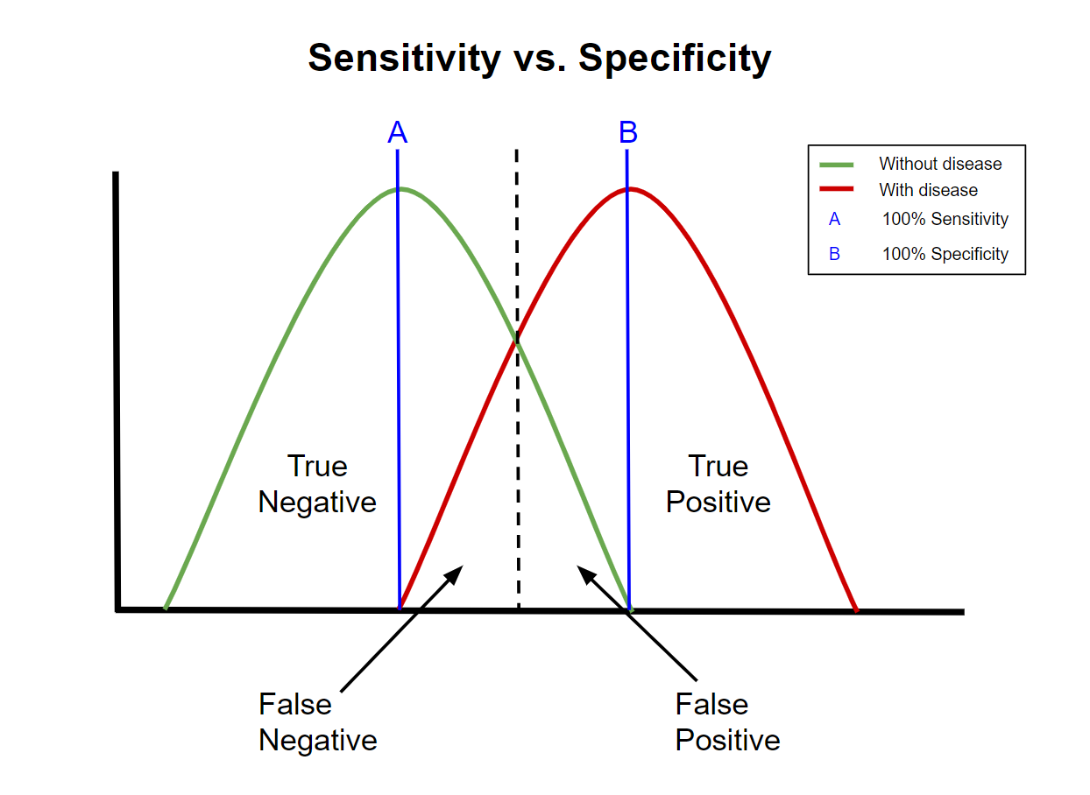

Furthermore, failure modes related to structural integrity, electrical malfunctions, and battery issues also pose significant risks. Instances such as Rust Formation, Short Circuits, and Battery Exposure to Moisture exhibit varying degrees of severity and detectability, but their occurrence rates and potential impacts necessitate thorough preventive measures. These measures may include regular inspections, enhanced quality control during assembly, and design modifications to improve resilience against environmental factors.

In addressing these high-risk scenarios, it is imperative to implement robust mitigation strategies. This could involve rigorous testing protocols during production, comprehensive user training to enhance the detectability of issues, and proactive maintenance schedules to mitigate potential failures before they escalate. Additionally, clear documentation outlining troubleshooting procedures and emergency protocols can empower users to respond effectively to unforeseen circumstances, reducing the likelihood of catastrophic outcomes.

By prioritizing risk mitigation efforts for high RPN value items identified in the FMEA, we can enhance the safety, reliability, and functionality of our device, ensuring optimal performance and user satisfaction while minimizing potential liabilities and hazards.

## Risk Mitigation Strategies

Looking more into failure modes with Risk Priority Number (RPN) values exceeding 64 will demand urgent attention and robust mitigation measures. Short circuits are a major risk for this device, with an RPN of 144. To mitigate the risk from happening, the device requires meticulous assembly quality control and wiring inspections. Battery-related risks are another risk for this device, including exposure to moisture and overheating (RPN > 100). In order to mitigate this risk, it is necessary to ensure proper protocols and locations for battery usage and moderate monitoring. Additionally, addressing the risk of Power Loss (RPN = 96) requires redundant power supply systems and proactive component replacement schedules because more usage of power could overwhelm the power system which can shut down the power if the power system that is linked with the device is not strong enough. Prioritizing these high-risk failure modes and implementing targeted mitigation strategies will enhance device reliability and user safety.

# **Societal Impact**

# 

## Value Proposition

The Biorefrigerator Security System design improves on existing CLE locking systems by combining the security measures of alarms and identifying users with an automatic closing system. These security measures not only prevent the lock from opening, but they are also able to alert nearby users of the CLE doors being left open. The device design uses preventative as well as corrective measures to protect biological samples in the CLEs.

There is not a widespread solution for a CLE locking system that is reasonably priced and easily accessible. This device will help reduce the risk of CLE’s opening spontaneously or being left open by the user, which can impact the laboratory samples inside the CLE, by ensuring that the CLE door is closed to protect the laboratory samples from decaying. There are existing solutions for CLE locks, but they are not widespread and they are expensive. The customer can benefit from having a secure system to protect their CLE in the lab while also not being too pricey. The combination of an alarm, PIN pad, and lock system means that the device will have advantages with different security features all in one device. The device will have a way to notify the user about an open CLE using an alarm, a way to unlock the CLE and to shut off the alarm using a PIN pad, and a way to keep the CLE closed using a lock system with a pressurized door closer. The combination of both an alarm and a PIN pad system can benefit laboratory users since there is a way to secure the CLE as a preventative measure to ensure the CLE stays shut while ensuring that when the foolproof measure fails, laboratory users can be easily notified by a visible and audible alarm, which in turn will prevent disasters such as losing cells and data. The amount of time saved from having an audible and visual alarm is immense as an alarm system can quickly notify nearby people a CLE is not closed all the way, rather than someone finding out eventually without realizing that the CLE is open when it should not be.

## Ethical Considerations

The Biorefrigerator Security System is designed to minimize the risk of data loss and reduce the possibility of demoralization due to the associated loss of time and money. Due to the security measures included with the device design, some ethical concerns about researchers’ autonomy, mistrust and privacy arise. Researchers’ autonomy may be infringed upon as a result of the device due to the restriction of materials. However, as CLEs in shared laboratories are typically not shared this should prove to not be a major issue. For mistrust and privacy issues, the introduction of alarms and activity monitoring could lead to a loss of trust from laboratory workers and an undermining of collaborative efforts. The lock design will create accountability for laboratory workers, however this accountability can also be seen as overbearing and may foster tension between workers and managers.

An IRB test is not needed since there is no direct human or animal testing involved, but any test that involves another person’s CLE’s would have to have their informed consent by informing them of a potential test of the lock in their CLE’s before conducting the test. There are three main principles in IACUC: replacement, reduction, and refinement. While animal testing is not used for this project, the principles of the IACUC can still be applied. There will not be a lot of replacing for locks as locks tend to last for a long time, so there can be fewer locks manufactured since they are meant for long term usage, hence meeting the reduction principles for IACUC. This project meets the replacement principles for IACUC since the project avoids using animals as animals are not necessary to test on for locks. The refinement processes are applied to the project as the CLE’s and locks will be treated with great care during the testing and the usage of the locks. The data that will be collected, particularly involving the saving of the passwords so that the user can input in a password to unlock and lock the PIN pad for the lock, will be protected to ensure that the design meets HIPAA standards regarding protecting user data by ensuring that the password, once entered, will be difficult to be hacked, so random people cannot access the CLE without knowing the password.

## Green Engineering

Figure 5: Green Engineering

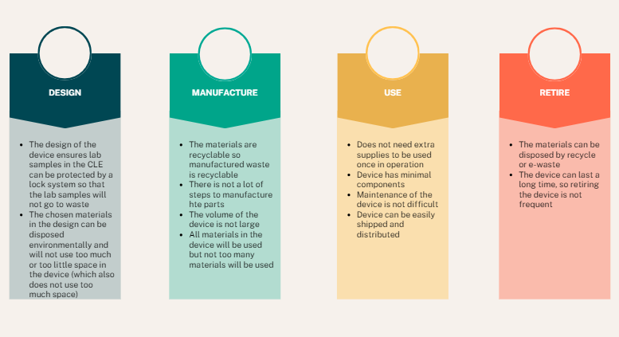

**Design** - The design of the lock maximizes efficiency and productivity by minimizing size and wasted space. By ensuring all components are as close together as possible, the amount of material is minimized, allowing for less potential waste. Furthermore, by how the device functions, waste of samples is minimized as well since the chance of the samples denaturing due to an open CLE is greatly decreased because the lock will ensure that the CLE is closed and the pin pad and alarm will hold the laboratory workers to be accountable for the CLE to be closed if it is open.

**Manufacture** - The main material used in manufacturing the device is stainless steel, as seen in our Bill of Materials in the appendix. Stainless steel can be recycled very easily. This means that any waste material can be recycled. Additionally, we are minimizing subtractive manufacturing. Our subtractive manufacturing consists of laser cutting the stainless steel and milling a small channel for wires in the back of the pressurized closer. All other manufacturing types will be either additive (eg. inserting components into slots in the case) or neutral (eg. welding steel sheets together to make the case). All other parts in manufacturing will be used eventually, such as screws and electrical components, so nothing else on the BOM has the potential to be wasted. While some parts will be made of plastic, such as internal brackets that will be 3D printed, these parts will be minimized in order to increase the overall recyclability.

**Use** - The lock is designed to be used for a long period of time, as typical locks that are made of steel, brass, zinc or various alloys do not get replaced often. The only use of the lock is to use the pin pad for unlocking the alarm when the alarm is heard or seen, so there is no part of the lock that is wasteful or unnecessary to have since there is only one function for users to control. Furthermore, the device has minimal components besides a pin pad for users to directly interface with, so the device is not complicated. The device can be used anywhere without issues with transport, so there is no need to waste anything to help move the device when it can be moved with just hands. Additionally, maintenance of the device is not difficult as the most that needs to be done is simply unscrewing the outer part of the device to check on problems rather than using up emissions to go to a specialized mechanic to fix the device. The lock will be distributed easily as it can be easily shipped to anyone since the size is small and there are no special steps for it to be distributed, especially since the lock is not large and it can be attached on any type of CLE. Moreover, since the battery is meant to both be long lasting and easily changed, the device’s lifetime should ideally be as long as 9V batteries are being produced. Furthermore, the only point of user interaction is the PIN pad, which reduces user wear and tear. Since epoxy can be removed with acetone, the lock can also be relocated with no damage to the CLE and re-mounted on another CLE. For transportation and distribution, due to the small size and durable components, the amount of packaging needed can be minimized. For repairs, the back of the device can be removed which allows users to attempt to fix the device themselves instead of ordering replacements.

**Retire** - The metal involved, stainless steel, is highly recyclable, meaning that any form of waste involved in the manufacturing can be recycled. Besides steel, there is not much other waste for the device besides recycling that needs to be specifically checked besides wiring and batteries in the e-waste. Disposal and replacement of these locks do not happen often, so the locks are not thrown in the waste often. The device can also be used for a long time before retiring, so there is no need to retire the device frequently since a lock can last a long time. Moreover, the batteries that will be used in the device are meant to be long lasting so that the amount of times the batteries need to be disposed of is minimal, and the device can also support environmentally friendly batteries being placed in it. If the user decides to use rechargeable batteries, then that also eliminates waste as we won’t need to dispose of them.

## Regulatory Pathway

The device that we have decided upon is not classified as a medical device under the FDA [6]. However, given that this device will be used in the same space as medical devices, we have decided to subject the device to Class 1 medical device regulations. Class 1 medical devices are non-life sustaining or life-supporting, and pose minimal risk of harm to their user. The automatic closer design that we have selected fulfills these requirements, and thus is subject to General Controls. The requirements of the General Controls are the prohibition of adulteration and misbranding, required registration and listing, restricted sale and distribution or use, adherence to Good Manufacturing Practices, and notification of risks, repairs, replacement or refund. The design of the Biorefrigerator Security System will prevent use of the device to perform a function besides closing and locking doors. The device will be registered and listed as the final device is prototyped. The sale and distribution of the device will be restricted similarly to CLEs as the two devices are meant to go together. Good Manufacturing Practices(GMP) refer to the regulation and upkeep of standards in products, people, processes, procedures, and premises[3]. Table 6, the FMEA table, is meant to notify users of the risks associated with the device.

The regulatory route that is appropriate for the Biorefrigerator Security System is the exempt regulatory path. The Biorefrigerator Security System falls under the category of “General hospital and personal use devices'' from 21 CFR Part 880. The FDA has exempted most class 1 devices, and in the event that a device falls under a generic category listed in 21 CFR Parts 862-892, that device is exempt from a premarket notification application [4]. In addition, the regulation description of “general purpose laboratory equipment labeled or promoted for a specific medical use” is listed as a product classification that is 510(k) exempt[5]. The device that we have created falls under this regulation description, similar to how freezers are as well.

# **References**

# 

[1] T. Rakow, S. El Deeb, T. Hahne, D. A. El‐Hady, H. M. AlBishri, and H. Wätzig, “Investigating effects of sample pretreatment on protein stability using size‐exclusion chromatography and high‐resolution continuum source atomic absorption spectrometry,” Journal of Separation Science, vol. 37, no. 18. Wiley, pp. 2583–2590, Aug. 2014. doi: 10.1002/jssc.201400189.

[2] “Ergonomic Guidelines for Manual Material Handling,” NIOSH. Accessed: Mar. 06, 2024. [Online]. Available: <https://www.cdc.gov/niosh/docs/2007-131/pdfs/2007-131.pdf>.

[3] “Adjusting Doors for Access,” ADA. Accessed: Mar. 06, 2024. [Online] Available: [https://adata.org/factsheet/adjusting-doors-access#:~:text=Interior%20doors%20should%20require%20no,not%20“jerk”%20it%20open](https://adata.org/factsheet/adjusting-doors-access#:~:text=Interior%20doors%20should%20require%20no,not%20%E2%80%9Cjerk%E2%80%9D%20it%20open)

# 

[4] “What are the 5 Key Components of Good Manufacturing Practice (GMP)?,” PharmOut. Accessed: Mar. 02, 2024. [Online]. Available:<https://www.pharmout.net/the-5-ps-of-gmps/>

[5] “Medical Device Exemptions 510(k) and GMP Requirements.” Accessed: Feb. 29, 2024. [Online]. Available:<https://www.accessdata.fda.gov/scripts/cdrh/cfdocs/cfpcd/315.cfm?GMPPart=610#start>

[6] “How to Determine if Your Product is a Medical Device,” FDA. Accessed: Mar. 06, 2024. [Online]. Available: <https://www.fda.gov/medical-devices/classify-your-medical-device/how-determine-if-your-product-medical-device>.

# 

# **Appendix**

# 

## Figure 6: House of Quality

## 

## 

## Preliminary Verification Test Protocols

The goal of Verification tests is to confirm all materials in use are not malfunctioned or dead on arrival. This is to ensure that no other factors can affect future tests. This phase includes an assessment of the battery, microcontroller, and closer. Afterward, we will test components as a subsystem and finally test the entire system overall.

**Battery**

*Purpose:* To ensure that the circuitry and program are effective when active, we must confirm the batteries are properly working. Testing will involve measuring voltage and battery life.

*Test Protocol:*

1. Turn on the multimeter
2. Turn the dial to the voltage setting 15V
3. Touch the red probe to the positive terminal and the black probe to the negative terminal
4. Note the voltage shown
5. Perform an average and standard dev.
6. After getting voltage, test for maH using the multimeter over 1 minute, then divide by 1000 to get aH
7. After getting maH, test how much energy the microprocessor draws using the multimeter over 1 minute (both idle and when activating the servo)
8. The battery life is now: V*aH(battery) / wH(microprocessor) to get the hours that the battery will last
9. The acceptable range is 6-12 months
10. Obtain data from other sources and base our results on results from data

**Microcontroller Component Testing**

*Purpose:* By testing each component of the Arduino, we will effectively find any defect that might exist before Validation testing.

*Standards To Meet:* IEC 60601-1-8 Ed. 2.2 b:2020 | Occupational Safety and Health Standard 1910.95 | IEC 63356-2 Ed. 1.0 b:2022

*Test Component Protocols:*

Adafruit METRO M0:

1. Turn on the AdafruitMETRO
2. Install Arduino IDE into METRO
3. “Hello World”
   1. See if it outputs the code
   2. Code in for a simple LED system, with a resistor
      1. Test for AdafruitMETRO, if code works with circuitry, then Adafruit works
      2. Possibly test for multiple pins

Red and Green LED:

1. Add a resistor in series with each cathode
2. Plug into the microcontroller and output 2.1V into the red LED pin
3. See if the red LED lights up
4. Turn off the 2.1 V output
5. Output 2.4 volts into the green LED pin
6. See if the green LED lights up
7. Turn off the 2.4V output

Pin Pad:

1. Activate and program in a certain passcode for the pin pad
2. Type in the passcode
3. If the correct passcode is entered, the lock status will change to “unlocked”

Speaker:

1. Use the METRO to program an alarm sound of frequency 1 Hz and 100% volume level
2. Measure the sound level from 2 feet away
   1. If the sound level is higher than 85 dB, adjust until it is 85 dB or lower
   2. If the sound level is inaudible or softer than the conversational level, the speaker has failed

Resistor:

1. Turn on the multimeter
2. Turn the dial to the resistance setting 20kΩ
3. Touch the red probe to one of the metal wires on the resistor and the black probe to the other wire
4. Note the resistance shown

Servo

1. Program in code with specific angle degrees
2. Note the initial position of the servo, then Note the new position of the servo with the programming, if the difference between the new position and initial position is set similarly to the programmed code, then the servo works.

Limit Switch

1. Turn on the multimeter
2. Turn the dial to the lowest resistance setting
3. Touch the test leads to the terminals of the limit switch
4. Press down the lever arm of the limit switch
5. Note the resistance from the multimeter
6. Release the lever arm
7. Note the resistance
8. Resistance should be low when the lever is pushed down, and high when released

LCD Screen

1. Connect screen to METRO
2. Code METRO to output a 32-character long word to screen
3. See if all cells on the screen can display a character

**Closer:**

*Purpose:* As the main component of the device, testing the closer will be important so that the status of the door can change with the closer component present.

*Standard To Meet:* ANSI/BHMA A156.4-2019

*Test Protocol:*

1. Test the range of motion of the closer arms
   1. The segment of the arm directly connected to the rack and pinion should have a range of motion of approximately 360 degrees
   2. The other segment of the arm should have a range of motion of approximately 180 degrees
2. Install the device onto the intended controlled laboratory environment
3. Test the Air Pressure Release Valve
   1. Open and close the door of the laboratory environment and observe the security and smoothness of closing. The door should close smoothly without slamming

**Attachment System (epoxy)**

*Purpose:* An epoxy attachment system is how the lock system is attached to the CLE. This test is required to ensure the system can be applied properly on the CLE.

*Test Protocol:*

1. An L-shaped stainless steel plate with a hole drilled through the exposed arm will be epoxied onto a stainless steel test device
2. Attach a luggage scale to the stainless steel plate
3. Pull the luggage scale until the plate comes off
4. Note the scale reading of the maximum force required to pull the plate off

**Microprocessor Subsystems:**

*Purpose:* These tests are final testing before the whole system is tested together. This test will be used to confirm circuit and programming aspects work effectively together before taking into account the physical aspect of the device

*Standards To Meet:* IEC 60601-1-8 Ed. 2.2 b:2020

*Test Protocol:*

1. Alarm
   1. Connect the speaker and LED to the Adafruit Metro in accordance with the circuit schematic
   2. Program the speakers and LED to alarm when the limit switch detects an open door and to turn off when it detects a closed door
      1. Press down on the limit switch and print the current door status to the display
      2. Ensure that the current door status displayed is “closed”
      3. Release the limit switch and print the current door status to the display
      4. Ensure that the current door status displayed is “open”
2. PINpad/Lock system
   1. Connect PIN pad and screen to METRO
   2. Program the lock to activate and deactivate off a default code (1111) then test if it does so
      1. Connect the PIN pad and servo to the Adafruit Metro
      2. Set the door lock status to be “locked”
      3. Print the current door lock status to the display
      4. Input the default code into the PIN pad
      5. Print the current door status to the display, which should now be “unlocked”. The Servo arm should rotate upwards and not block the closer arm
      6. Input the default code into the PIN pad
      7. Print the current door status to the display, which should now be “locked”. The Servo arm should rotate downwards and block the closer arm

**The Whole System Must Be Tested**

*Purpose:* As the final test, this test will be done to ensure the entire system all together is effectively working as it properly should.

*Test Protocol:*

1. The system locks the door when necessary, closes the door in most cases, and sounds an alarm when specified
2. Test system similar to an intended day in the lab
   1. Unlock the system with the pin pan to unlock the servo
   2. Open the door and close it and test if the system detects the door is closed
   3. Test leaving the door open for 3 minutes and test when the speaker and LED go off
      1. Note: the system is supposed to alarm at 2 mins. Testing for 3 minutes will help discover unwanted or unnoticed factors.
   4. Repeat the previous two tests a couple of times
   5. Close the door, final test, if the alarm detects the door, is closed
   6. Lock the system using the pin pad

## 

## 

## 

## 

## 

## 

## 

## 

## 

## 

## 

## 

## 

## 

## 

## 

## Figure 7: Circuitry Diagram

## Table 6: Complete Failure Modes and Effects Analysis

| Item | Potential Failure Mode | Potential Causes | O | Potential Effect | S | Current Controls | D | RPN (S x O x D) | Migration Strategy/ Actions Recommended |
| --- | --- | --- | --- | --- | --- | --- | --- | --- | --- |
| Alarm | False Negative  on speaker | (i) The speaker itself may be damaged  (ii) The limit switch is damaged  (iii) Loose connections  (iv) wiring damage | 1 | The audio alarm will not sound making it difficult to know if the lab door is left open. | 8 | When the device is being assembled, check functionality of the speaker, limit switch, and wire connections. | 6 | 60 | Establish monthly routine check-ups. Ensure verification of the completed system (ex: A door open for too long causes Speaker and LED alarm to activate) |
|  | False Negative on LED | (i) The LED itself may be damaged  (ii) The limit switch is damaged  (iii) Loose connections  (iv) wiring damage | 1 | The LED alarm will not light, making it difficult to know if the CLE door is left open | 8 | When the device is being assembled, check functionality of the LED, limit switch, and wire connections. | 6 | 60 | See above |
|  | False Positive on speaker | (i) The limit switch may be stuck  (ii) crossed wires | 4 | The sound will be audible and the user thinks the door is open when it is still closed. | 3 | Check wire connections during assembly. Design the case with ample wiring space and include cable routing brackets. | 1 | 12 | See above |
|  | False Positive on LED | (i) The limit switch may be stuck  (ii) crossed wires | 4 | The light will turn on making nearby users believe the door is open when it is not | 3 | Check wire connections during assembly. Design the case with ample wiring space and include cable routing brackets. | 1 | 12 | See above |
| Security | Accepts incorrect PIN code | (i)Software malfunction (ii)crossed wires may change the received passcode from the one input | 1 | The CLE could be unlocked when not supposed to. | 5 | Thoroughly test the PIN pad circuit during verification. Check wire connections during assembly. Design the case with ample wiring space and include cable routing brackets. | 6 | 30 | Provide circuit diagram and review and fix as needed.  Wipe previous passcode data, Reinput new passcode |
|  | Rejects correct PIN code | See above | 1 | The CLE could be not unlockable. | 3 | Thoroughly test the PIN pad circuit during verification. Check wire connections during assembly. Design the case with ample wiring space and include cable routing brackets. | 1 | 3 | See above |
|  | Servo does not rotate all the way | (i)Buildup of debris may limit the range of motion of the servo  (ii) Manufacturing error | 4 | The lock will not properly open or close at the specific angle it should, resulting in difficulty in opening the CLE doors and/or damage to the servo and hook assembly | 6 | Test the servo during validation. Design the servo mount with enough space to clean the servo if needed | 2 | 48 | Replace or provide instructions for maintenance of the component. Pressurized air or a cloth may be used to clear debris in the gaps |
| Pressurized Door Closer | Door does not close all the way | (i)Insufficient closing pressure  (ii) physical obstruction of the CLE door | 1 | The door could be left open, which can negatively impact samples in the CLE. | 1 | The closer is equipped with values to change closer pressure. The alarms are coded to sound after the doors are open for a specified length of time in case of physical obstruction | 4 | 40 | See above |
|  | Excessive closing pressure | (i) improperly tuned sweep speed  (ii) improperly tuned latch speed | 2 | The CLE door could be slammed shut, jostling the contents inside. | 4 | The closer is equipped with values to change closer pressure | 2 | 16 | See above |
| Epoxy | Failure to stick to the intended CLE | (i) manufacturing defect  (ii) Not allowing for the full curing time  (iii) insufficient adhesive coverage  (iv) unclean application surface | 3 | The lock could fall off, meaning that the lock cannot be used properly. | 8 | Device adhesion surfaces are designed with large surface areas | 1 | 24 | Ensure that when applying export, appropriate time and amount must be given to the epoxy before use |
|  | Sticks to user during assembly | (i) touching the epoxy resin during installation | 5 | The sticking could be hard for the user to remove from themselves. | 4 | None | 1 | 20 | Ensure that when applying epoxy, appropriate protection is used to prevent the epoxy from sticking on the user. |
|  | Inhalation of epoxy fumes | (i) poor ventilation during assembly | 5 | Skin, eyes, nose, and throat irritation. Possible trigger for skin allergies and asthma | 5 | None | 2 | 50 | Ensure that when applying epoxy, application is done where it is well ventilated or provide masks as needed. |
| Electrical | Short Circuit | (i) Water damage  (ii) Faulty wiring  (iii) Loose connections  (iv) Overheating | 3 | The circuitry for the whole device would not function, resulting in possible lock failure. | 8 | Check wiring during verification and assembly. Designed with space between components to improve air flow | 6 | 144 | Disassemble the PIN Pad casing and assess the current state of the internal components. Ensure complete connections. Replacement of damaged components may be necessary based on the severity of the damage. |
| Structural | Rust | (i) Exposure to moisture  (ii) Exposure to acids  (iii) Contact with dissimilar metals | 2 | The lock could potentially degrade over time due to rust, potentially with a small risk of loss of the function of moving parts such as the servo, arms, or rack and pinion system. | 3 | Check the assembled device for any gaps. Device was designed to be positioned away from any possible spills | 2 | 12 | Proper controls are deemed sufficient |
|  | Material Wear | (i) friction | 3 | Degradation over time due to friction, potentially with a small risk of loss of the function of moving parts such as the servo, arms, or rack and pinion system. | 3 | Device was built with tough materials to withstand many use cycles, and will be smooth to reduce friction | 2 | 18 | Proper controls are deemed sufficient |
|  | Epoxy Buildup/residue | (i)excessive adhesive usage  (ii)drip during installation | 4 | Uncured epoxy resin may cause skin irritation, respiratory issues and may be flammable. Cured epoxy resin will only pose aesthetic issues | 2 | None | 2 | 16 | Ensure that instructions provided to the user tell them to use an appropriate amount of epoxy. Otherwise, give instructions to use epoxy remover |
|  | Moisture Damage | (i) condensation from the CLE  (ii) Liquid spills | 4 | Rust and damage to electrical components | 6 | Check the assembled device for any gaps. Device was designed to be positioned away from any possible spills | 6 | 144 | If there is any moisture, check the immediate area and also if there are any gaps in the device as well as check inside the CLE and fix the problem immediately. |
|  | Thermal Expansion | (i) heating from the electrical components  (ii) heating from the CLE | 2 | Expansion of materials and components may reduce the available space and lead to crowding. | 2 | Check wiring during verification and assembly. Designed with space between components to improve air flow | 6 | 24 | Check the temperatures in the electrical components and CLE and if it's not cold enough, adjust the temperature. |
| Battery | Exposure to moisture | (i) condensation from the CLE  (ii) Liquid spills | 4 | A battery with moisture would have its function impaired due to reduced resistance | 7 | Check the assembled device for any gaps. Device was designed to be positioned away from any possible spills | 4 | 112 | Remind the user that the device must be placed away from moisture and in a clean and dry area before applying |
|  | Overheating | (i) heating from the electrical components  (ii) heating from the CLE  (iii) Faulty wiring | 2 | A battery that is too hot will not function properly | 6 | Check wiring during verification and assembly. Designed with space between components to improve air flow | 6 | 72 | Disassemble the PIN Pad casing and assess the current state of the internal components. Ensure complete connections. Replacement of damaged components may be necessary based on the severity of the damage. |
|  | Battery dies | (i) Extended use | 2 | The lock will not work because there is no battery power. | 8 | None | 1 | 16 | Keep a stock of 9V batteries. Replace at appropriate/said times on the battery box |
|  | Acid Leak | (i) Physical damage to the battery  (ii) Extreme temperatures  (iii) Age | 2 | Corrosion of components and structural materials may occur. Users may also experience skin burns, inhalation irritation, and possible blindness if the acid come in contact with the eyes | 6 | None | 4 | 48 | Ensure that the batteries can be easily replaced every so often to ensure that there is no acid leak because of old and damaged batteries. Make the battery replacement user friendly and not complicated. |
| User | PIN Code is forgotten | (i) User forgets PIN code | 5 | The lock cannot be opened by this user | 2 | Master passcode will be provided to administrator, and will be included on documentation | 1 | 10 | Full system reset of the device. |
|  | Door is forced open when locked | (i) User ignores resistance of the hook mechanism  (ii) hook mechanism malfunction | 2 | If the door is opened when locked, then damage to the servo, hook, and arms is possible. | 6 | Alarms are in place to prevent this, and the servo and hook assembly provides resistance to opening when the device status is “locked” | 2 | 24 | If there’s resistance to opening, check if the LED is green |
| Manufacturing | Loose device structural connections | (i) Loose screws  (ii) Improper tolerances | 4 | The lock structure could be unstable, which could prompt anywhere from the lock not functioning to the lock structure to break. | 5 | Manufacturing within standard tolerances, and ensuring properly tightened screws and connections during verification and assembly | 4 | 80 | Tighten loose connections with a screwdriver if applicable |
|  | Power does not transfer from the microcontroller | (i)Faulty wires  (ii)Damage to the microcontroller  (iii)Loose connections  (iv)Battery issues listed above | 2 | The lock will simply not function at all as it does not have the power needed. | 8 | Test battery and microcontroller during verification, check wiring during assembly | 3 | 48 | Disassemble the PIN Pad casing and assess the current state of the internal components. Ensure complete connections. Replacement of components may be necessary based on the cause. |

*A false positive means that the device reports the CLE as open when it is closed

*A false negative means that the device reports the CLE as closed when it is open

## Table 7: Engineering Design Specifications

## 

| Metrics | Units | Corresponding User Needs | Range | Target Value | Direction of Improvement |
| --- | --- | --- | --- | --- | --- |
| Price | US Dollar | Affordability | $14-$984 | $300 | To be minimized |
| Battery Life | Weeks | Power Delivery | 1- | 8 | To be maximized |
| Passive Operation | Binary | Ease of Handling | Fully Active to Fully Passive | Mostly Passive | To be maximized |
| Number of Components | Numerical | Ease of Manufacturing | 10-100 | 20 | To be minimized |
| Established Technology | Binary | Practicality | Yes or No | Yes | N/A |
| Weight | Pounds | User Friendliness | 1 to 8 | 7 | To be minimized |

## 

## Table 8: Bill of Materials

| **Component** | **Material** | **Purchasing Location** | **Part Number** | **Quantity** | **Weight** | **Price Per Unit** | **Total Price** | **Notes** | **Link** |
| --- | --- | --- | --- | --- | --- | --- | --- | --- | --- |
| 18 Gauge Steel Sheet | Mild Steel | Amazon | B08GFXMXNG | 2 packs of 2 | 2.84 lbs per sheet | $29.90 | $59.80 | Alternative Body for case | [Steel Sheet](https://a.co/d/a3CqhTq) |
| **Screws** | 18-8 Stainless Steel | McMaster-Carr | 97613A529 | 1 | ~0 | $17.36 | $17.36 | For the Body attachment. 10 Pack | [Screws](https://www.mcmaster.com/97613A529/) |
| **Adafruit METRO M0** | Microcontroller | Adafruit | 2488 | 1 | 0.042 lbs | $17.50 | $17.50 | Coding component for alarms, PIN pad, potentiometer | [Adafruit METRO](https://www.adafruit.com/product/3505) |
| **Red and Green Indicator LED** | LED | Adafruit | 4042 | 1 | Not Available | $1.75 | 1.75$ | Light Alarm | [RED/GREEN LED](https://www.adafruit.com/product/4042) |
| **PIN Pad** | N/A | Adafruit | 3845 | 1 | ~0 | $6.50 | $6.50 | The PIN pad itself | [PIN Pad](https://www.adafruit.com/product/3845) |
| **Wires** | PVC Coated Copper | Amazon | B08BBXTBL7 | 1 | 0.79 lbs total | $14.94 | $14.94 | Wiring for the device | [Wires](https://www.amazon.com/Gauge-Wire-Solid-Core-Hookup/dp/B08BBXTBL7/ref=sr_1_4?crid=2YFKFOA4RD63X&dib=eyJ2IjoiMSJ9.UIo5E3q7NzPjkxQwKGNfdQ3FuhAzLC-mAshupgLoSkDXkWJc1I1QggnkW8dAvnQAoPGPPllbJenMA18wVx0t9j-gmsoh0NwyJyPDq3IPxBP2T55pKQpW10vA9NtuKP_kZATr4Ul6AlKtvMASqldw9Q.xbG82dSqDf78ub71xgXVEjiEBb7RhIcGF8l26PJFpKs&dib_tag=se&keywords=wires&qid=1705265164&s=hi&sprefix=wire%2Ctools%2C199&sr=1-4) |
| **Potentiometer** | Potentiometer | Adafruit | 562 | 1 | Not Available | $0.95 | $0.95 | 10k kiloohms | [Potentiometer](https://www.adafruit.com/product/562) |
| **Adhesive (Epoxy)** | Epoxy Resin | Amazon | N/A | 1 | 0.125 lbs total | $12.45 | $12.45 | 2 pack, Metal Adhesive | [Epoxy Resin](https://www.amazon.com/J-B-Weld-Original-Reinforced-Strength/dp/B0B5VNG2YT/ref=asc_df_B0B5VNG2YT/?tag=hyprod-20&linkCode=df0&hvadid=598238944920&hvpos=&hvnetw=g&hvrand=16027891236110708106&hvpone=&hvptwo=&hvqmt=&hvdev=c&hvdvcmdl=&hvlocint=&hvlocphy=1013763&hvtargid=pla-1695224676408&mcid=13a156f4cdf13c26a20bfeb5266c44ce&gclid=CjwKCAiAqY6tBhAtEiwAHeRopf2Vh7qsXWIDqrsuZjqCuv6-VXtDVUysLzUv1R-RMKNJFESZMiPzWBoCWzAQAvD_BwE&th=1) |
| **Speaker** | N/A | Adafruit | 1891 | 1 | 0.01 lbs | $1.75 | $1.75 | Speaker for the alarm | [Speaker](https://www.adafruit.com/product/1891) |
| **Pressurized Door Closer** | Aluminum | Amazon | ‎SOULONGg850ya231w | 1 | 2.31 lbs | $20.81 | $20.81 | Will use for hydraulic components | [Closer](https://www.amazon.com/Aluminum-Commercial-Automatic-Closing-Independent/dp/B08GPD3W6V/ref=asc_df_B08GPD3W6V/?tag=hyprod-20&linkCode=df0&hvadid=680463214693&hvpos=&hvnetw=g&hvrand=18051584580321407561&hvpone=&hvptwo=&hvqmt=&hvdev=c&hvdvcmdl=&hvlocint=&hvlocphy=1013721&hvtargid=pla-2260095885309&psc=1&mcid=624b2ed7d3513a4e9b84fd5e8e249870) |
| **Internal Brackets and other small parts** | PLA | UC Davis | N/A | As needed | ~0 | Variable | Variable |  |  |
| **Resistor** | 10kΩ 5% | Adafruit | 2784 | 1 pack | ~0 | $0.75 | $0.75 | For voltage divider | [10kΩ resistor](https://www.adafruit.com/product/2784) |
| **Battery Holder** |  | Adafruit | 67 | 1 | 0.05lbs | $3.95 | $3.95 |  | [Battery Holder](https://www.adafruit.com/product/67) |
| **Servo** | Micro Servo | Adafruit | 2307 | 1 | 0.03lbs | $11.95 | $11.95 |  | [Servo](https://www.adafruit.com/product/2307) |
| **Battery** | 9V battery | Amazon | N/A | 1 pack of 4 | 0.05lbs | $9.55 | $9.55 | Power source for device | [9V battery](https://www.amazon.com/Amazon-Basics-Performance-All-Purpose-Batteries/dp/B0774D64LT?th=1) |
| **Sum of Prices/Weights** |  |  |  |  | ~7 lbs |  | $158.19 |  |  |

## 